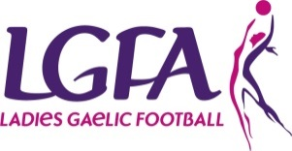
Club Cultural and Language Officer

Role Description
The role of the Club Cultural and Language Officer is to provide advice to the Clubs officers in supporting the National Language and Culture.

Reports/accountable to
- Chairperson/ Club committee

Responsibilities
- Act as Cathaoirleach of the Coiste Cultúr agus Teanga Contae (County Culture and Language subcommittee if in place) and to be a member of the Club Executive
- Provide a service/input for Club Publications/Programmes
- Liaise with other language and cultural groups within the County
- Liaise with Clubs regarding Cúrsaí Gaeilge
- Act as Club Scór co-ordinator if applicable
- Encourage the use of bi-lingual materials (signs etc...) within the Club.
- Administer Club Gaeltacht Scholarships Schemes if in place

SKILLS | KNOWLEDGE
- Have good written and spoken knowledge of the Irish Language (Gaeilge)  - Have good communication skills  - Ability to Delegate tasks  - Have good organisational skills  - Be IT literate | - Eolas mhaith ar an teanga dúchais agus ar chultúr traidisiúnta na tíre/ A good knowledge of the native language and the traditional culture of the country

OTHER REQUIREMENTS
- Have time to do the job
- Have a genuine interest in the Association
- Have a genuine interest in the Irish language and culture
- Be of good standing in the community

